Figure 6
Connections over 200 kbps in at Least One Direction 2013-2017
(In thousands)

 | 2013 | 2014 |  | 2015 |  | 2016 |  | 2017
Technology | Dec | Jun* | Dec | Jun | Dec | Jun | Dec | Jun | Dec
Total | 293,397 | 324,471 | 338,202 | 357,613 | 375,895 | 395,603 | 404,971 | 408,816 | 420,966
Total Fixed | 96,032 | 95,982 | 98,245 | 100,179 | 102,216 | 104,087 | 105,715 | 106,254 | 108,188
Mobile Wireless | 197,365 | 228,489 | 239,957 | 257,434 | 273,679 | 291,516 | 299,256 | 302,562 | 312,778

Figure 7
Residential Connections over 200 kbps in at Least One Direction 2013-2017
(In thousands)

 | 2013 | 2014 |  | 2015 |  | 2016 |  | 2017
Technology | Dec | Jun* | Dec | Jun | Dec | Jun | Dec | Jun | Dec
Total | 246,797 | 277,551 | 290,696 | 306,292 | 322,557 | 341,537 | 349,607 | 353,057 | 365,040
Total Fixed | 87,599 | 87,345 | 89,530 | 91,439 | 93,434 | 95,001 | 96,607 | 97,071 | 98,832
Mobile Wireless | 159,197 | 190,205 | 201,166 | 214,853 | 229,122 | 246,537 | 253,000 | 255,986 | 266,208

* The June 2014 data have not been subjected to the typical quality checks (see Technical Notes).

The Commission approved changes to the Form 477 in June 2013 that affect the data beginning in June 2014 (see Technical Notes). Some previously-published
data may have been revised. Figures may not sum to totals elsewhere in this report due to rounding.

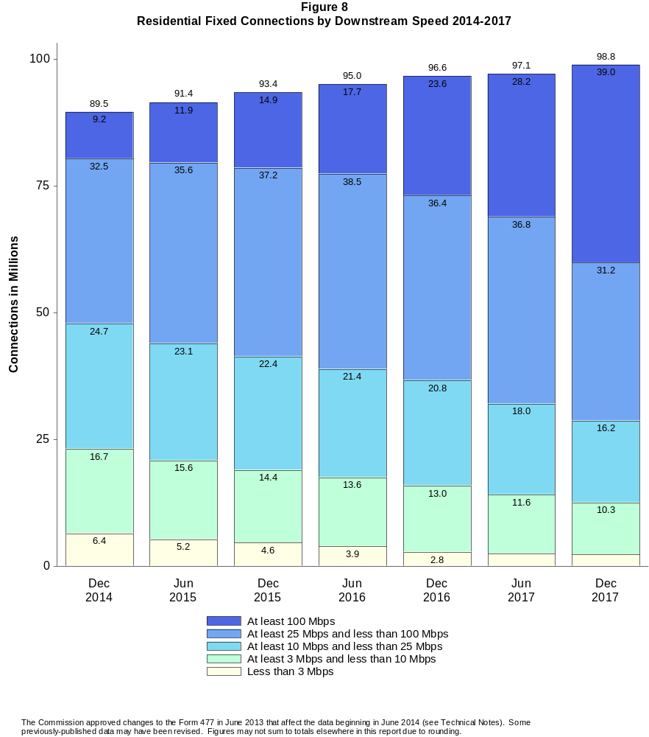

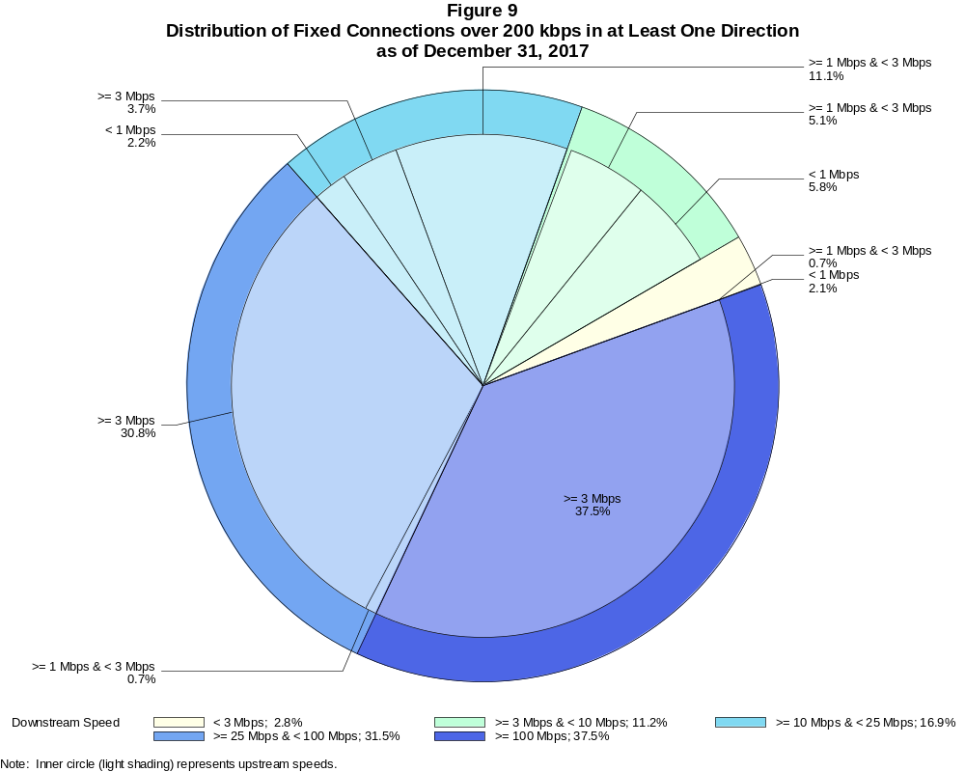

Fixed Connections over 200 kbps in at Least One Direction (in thousands)

 | Downstream Speed
Upstream Speed | Less than 3 Mbps | At least 3 Mbps  and less than 10 Mbps | At least 10 Mbps  and less than 25 Mbps | At least 25 Mbps  and less than 100 Mbps | At least 100 Mbps | Total
Less than 1 Mbps | 2,298 | 6,278 | 2,334 | # | # | 10,910
At least 1 Mbps & Less than 3 Mbps | 762 | 5,517 | 11,969 | 798 | 6 | 19,052
At least 3 Mbps | 4 | 301 | 4,003 | 33,305 | 40,612 | 78,226
Total | 3,064 | 12,096 | 18,306 | 34,104 | 40,618 | 108,188

Percentages

Less than 1 Mbps | 2.1 | 5.8 | 2.2 | 0.0 | 0.0 | 10.1
At least 1 Mbps & Less than 3 Mbps | 0.7 | 5.1 | 11.1 | 0.7 | 0.0 | 17.6
At least 3 Mbps | 0.0 | 0.3 | 3.7 | 30.8 | 37.5 | 72.3
Total | 2.8 | 11.2 | 16.9 | 31.5 | 37.5 | 100.0

Note: Figures may not sum to totals due to rounding. # = Rounds to zero.
Source: FCC Form 477.

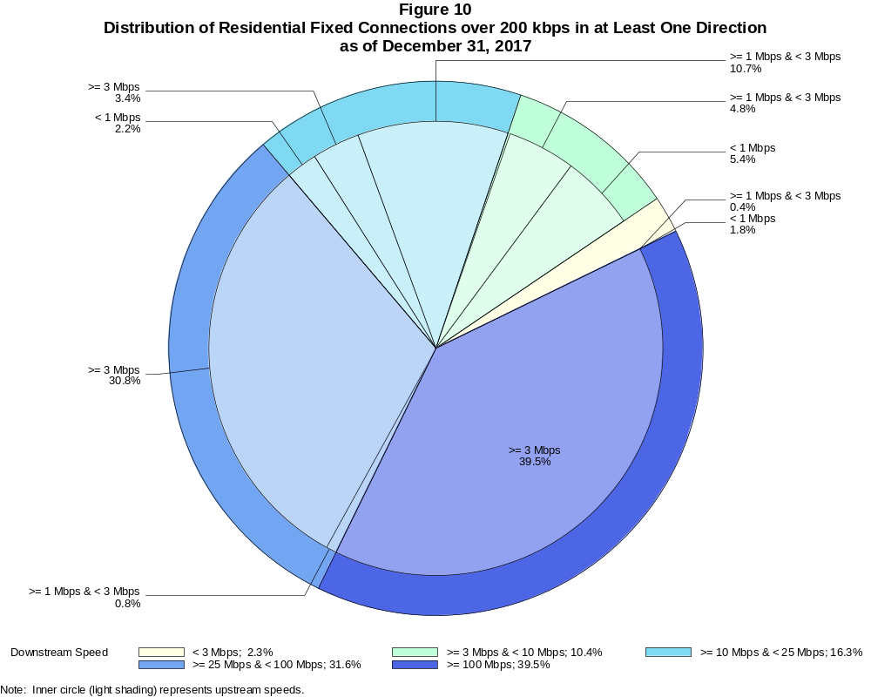

Residential Fixed Connections over 200 kbps in at Least One Direction (in thousands)

 | Downstream Speed
Upstream Speed | Less than 3 Mbps | At least 3 Mbps  and less than 10 Mbps | At least 10 Mbps  and less than 25 Mbps | At least 25 Mbps  and less than 100 Mbps | At least 100 Mbps | Total
Less than 1 Mbps | 1,809 | 5,315 | 2,194 | # | 0 | 9,318
At least 1 Mbps & Less than 3 Mbps | 417 | 4,789 | 10,600 | 742 | 5 | 16,554
At least 3 Mbps | 4 | 148 | 3,361 | 30,445 | 39,002 | 72,960
Total | 2,230 | 10,253 | 16,155 | 31,187 | 39,007 | 98,832

Percentages

Less than 1 Mbps | 1.8 | 5.4 | 2.2 | 0.0 | 0.0 | 9.4
At least 1 Mbps & Less than 3 Mbps | 0.4 | 4.8 | 10.7 | 0.8 | 0.0 | 16.7
At least 3 Mbps | 0.0 | 0.1 | 3.4 | 30.8 | 39.5 | 73.8
Total | 2.3 | 10.4 | 16.3 | 31.6 | 39.5 | 100.0

Note: Figures may not sum to totals due to rounding. # = Rounds to zero.
Source: FCC Form 477.

Figure 11
Connections over 200 kbps in at Least One Direction by Technology 2013-2017
(In thousands)

 | 2013 | 2014 |  | 2015 |  | 2016 |  | 2017
Technology | Dec | Jun* | Dec | Jun | Dec | Jun | Dec | Jun | Dec
Total | 293,397 | 324,471 | 338,202 | 357,613 | 375,895 | 395,603 | 404,971 | 408,816 | 420,966
Total Fixed | 96,032 | 95,982 | 98,245 | 100,179 | 102,216 | 104,087 | 105,715 | 106,254 | 108,188
aDSL | 30,690 | 29,870 | 29,533 | 29,351 | 28,134 | 27,488 | 26,527 | 25,506 | 24,193
sDSL | 108 | 96 | 72 | 77 | 60 | 55 | 42 | 44 | 28
Other Wireline¹ | 772 | 792 | 773 | 706 | 694 | 674 | 655 | 668 | 631
Cable Modem | 54,009 | 54,011 | 55,785 | 57,244 | 59,706 | 61,456 | 63,325 | 64,059 | 66,195
FTTP² | 7,745 | 8,312 | 9,077 | 9,688 | 10,498 | 11,143 | 12,053 | 12,906 | 13,978
Satellite | 1,849 | 1,964 | 2,006 | 2,058 | 2,071 | 2,079 | 1,864 | 1,826 | 1,872
Fixed Wireless | 858 | 935 | 999 | 1,056 | 1,054 | 1,192 | 1,250 | 1,245 | 1,292
Mobile Wireless | 197,365 | 228,489 | 239,957 | 257,434 | 273,679 | 291,516 | 299,256 | 302,562 | 312,778

¹ Power Line and Other are summarized with Other Wireline to maintain firm confidentiality. See Technical Notes at the end of the report for a description of
Form 477 technology categories and other reporting requirements.
² Fiber to the premises.
* The June 2014 data have not been subjected to the typical quality checks (see Technical Notes).

The Commission approved changes to the Form 477 in June 2013 that affect the data beginning in June 2014 (see Technical Notes). Some previously-published
data may have been revised. Figures may not sum to totals due to rounding.

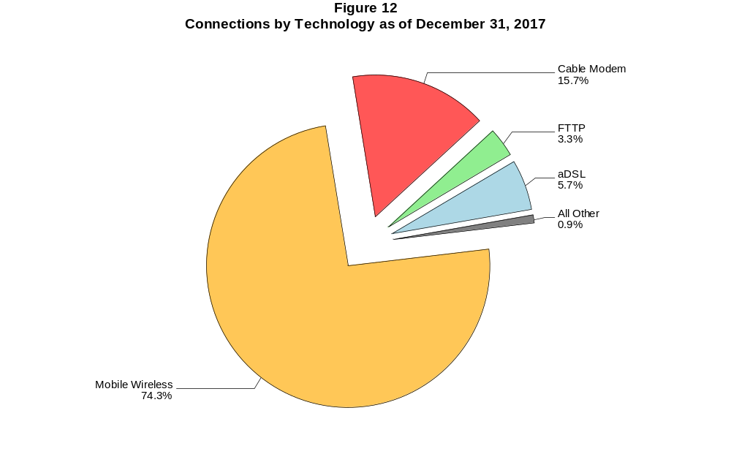

Figure 13
Residential Connections over 200 kbps in at Least One Direction by Technology 2013-2017
(In thousands)

 | 2013 | 2014 |  | 2015 |  | 2016 |  | 2017
Technology | Dec | Jun* | Dec | Jun | Dec | Jun | Dec | Jun | Dec
Total | 246,797 | 277,551 | 290,696 | 306,292 | 322,557 | 341,537 | 349,607 | 353,057 | 365,040
Total Fixed | 87,599 | 87,345 | 89,530 | 91,439 | 93,434 | 95,001 | 96,607 | 97,071 | 98,832
aDSL | 27,248 | 26,675 | 26,442 | 26,157 | 25,139 | 24,486 | 23,691 | 22,775 | 21,653
sDSL | 39 | 30 | 19 | 18 | 16 | 10 | 8 | 12 | 9
Other Wireline¹ | 22 | 57 | 59 | 59 | 54 | 51 | 32 | 74 | 68
Cable Modem | 50,709 | 50,389 | 52,061 | 53,544 | 55,799 | 57,358 | 59,145 | 59,687 | 61,567
FTTP² | 7,176 | 7,605 | 8,262 | 8,842 | 9,592 | 10,140 | 10,956 | 11,776 | 12,702
Satellite | 1,643 | 1,760 | 1,803 | 1,875 | 1,891 | 1,897 | 1,676 | 1,637 | 1,688
Fixed Wireless | 763 | 829 | 884 | 944 | 943 | 1,059 | 1,099 | 1,111 | 1,146
Mobile Wireless | 159,197 | 190,205 | 201,166 | 214,853 | 229,122 | 246,537 | 253,000 | 255,986 | 266,208

¹ Power Line and Other are summarized with Other Wireline to maintain firm confidentiality. See Technical Notes at the end of the report for a description of
Form 477 technology categories and other reporting requirements.
² Fiber to the premises.
* The June 2014 data have not been subjected to the typical quality checks (see Technical Notes).

The Commission approved changes to the Form 477 in June 2013 that affect the data beginning in June 2014 (see Technical Notes). Some previously-published
data may have been revised. Figures may not sum to totals due to rounding.

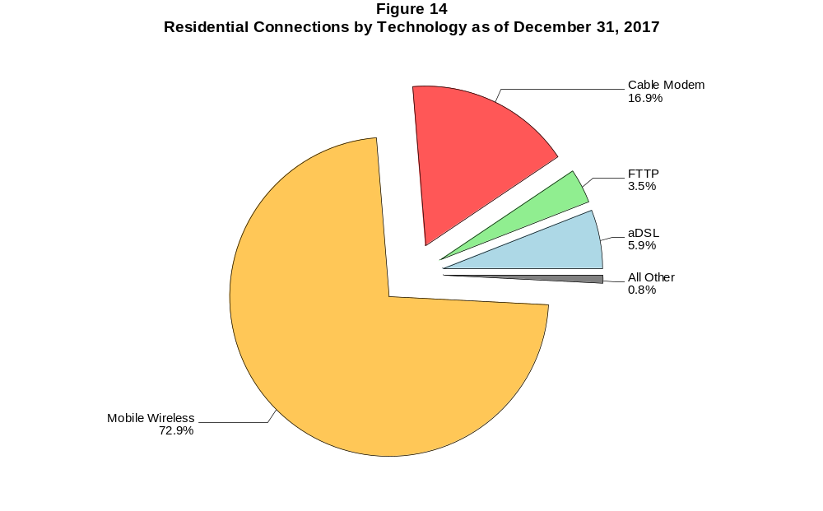

Figure 15
Fixed Connections at Least 3 Mbps Downstream and 768 kbps Upstream by Technology 2013-2017
(In thousands)

 | 2013 | 2014 |  | 2015 |  | 2016 |  | 2017
Technology | Dec | Jun* | Dec | Jun | Dec | Jun | Dec | Jun | Dec
Total | 78,175 | 78,981 | 83,872 | 89,011 | 92,356 | 95,516 | 98,761 | 100,098 | 102,035
aDSL | 18,540 | 17,246 | 18,557 | 20,947 | 20,744 | 21,147 | 21,042 | 20,621 | 19,257
sDSL | 36 | 33 | 28 | 24 | 20 | 20 | 20 | 24 | 17
Other Wireline¹ | 308 | 310 | 308 | 297 | 330 | 336 | 328 | 355 | 370
Cable Modem | 50,236 | 51,304 | 53,853 | 55,819 | 58,423 | 60,343 | 62,855 | 63,719 | 65,905
FTTP² | 7,486 | 8,111 | 8,974 | 9,552 | 10,383 | 11,030 | 11,953 | 12,813 | 13,870
Satellite | 1,181 | 1,424 | 1,558 | 1,690 | 1,744 | 1,775 | 1,609 | 1,586 | 1,563
Fixed Wireless | 388 | 553 | 594 | 681 | 712 | 865 | 954 | 981 | 1,054

¹ Power Line and Other are summarized with Other Wireline to maintain firm confidentiality. See Technical Notes at the end of the report for a description of Form
477 technology categories and other reporting requirements.
² Fiber to the premises.
* The June 2014 data have not been subjected to the typical quality checks (see Technical Notes).
# = Rounds to zero.

The Commission approved changes to the Form 477 in June 2013 that affect the data beginning in June 2014 (see Technical Notes). Some previously-published
data may have been revised. Figures may not sum to totals due to rounding.

Figure 16
Residential Fixed Connections at Least 3 Mbps Downstream and 768 kbps Upstream by Technology 2013-2017
(In thousands)

 | 2013 | 2014 |  | 2015 |  | 2016 |  | 2017
Technology | Dec | Jun* | Dec | Jun | Dec | Jun | Dec | Jun | Dec
Total | 72,476 | 73,042 | 77,540 | 82,320 | 85,439 | 88,197 | 91,258 | 92,354 | 93,977
aDSL | 16,715 | 15,673 | 16,867 | 18,988 | 18,866 | 19,207 | 19,133 | 18,719 | 17,480
sDSL | 13 | 7 | 2 | 1 | 2 | 2 | 3 | 7 | 6
Other Wireline¹ | 20 | 45 | 50 | 45 | 47 | 49 | 31 | 73 | 67
Cable Modem | 47,258 | 47,924 | 50,308 | 52,254 | 54,650 | 56,353 | 58,784 | 59,410 | 61,334
FTTP² | 6,958 | 7,491 | 8,246 | 8,750 | 9,512 | 10,063 | 10,883 | 11,704 | 12,616
Satellite | 1,177 | 1,419 | 1,552 | 1,682 | 1,734 | 1,764 | 1,596 | 1,571 | 1,545
Fixed Wireless | 335 | 483 | 516 | 599 | 628 | 759 | 829 | 870 | 929

¹ Power Line and Other are summarized with Other Wireline to maintain firm confidentiality. See Technical Notes at the end of the report for a description of Form
477 technology categories and other reporting requirements.
² Fiber to the premises.
* The June 2014 data have not been subjected to the typical quality checks (see Technical Notes).
# = Rounds to zero.

The Commission approved changes to the Form 477 in June 2013 that affect the data beginning in June 2014 (see Technical Notes). Some previously-published
data may have been revised. Figures may not sum to totals due to rounding.

Figure 17
Fixed Connections at Least 10 Mbps Downstream and 1 Mbps Upstream by Technology 2014-2017
(In thousands)

 | 2014 |  | 2015 |  | 2016 |  | 2017
Technology | Jun* | Dec | Jun | Dec | Jun | Dec | Jun | Dec
Total | 63,823 | 68,238 | 72,713 | 76,939 | 80,458 | 84,112 | 86,967 | 90,694
aDSL | 7,561 | 8,560 | 9,471 | 9,799 | 10,349 | 10,810 | 11,321 | 11,596
sDSL | 9 | 6 | 9 | 8 | 8 | 10 | 14 | 9
Other Wireline¹ | 169 | 186 | 182 | 203 | 210 | 217 | 253 | 273
Cable Modem | 47,296 | 49,837 | 52,658 | 55,710 | 57,951 | 60,349 | 61,704 | 63,977
FTTP² | 7,601 | 8,320 | 8,874 | 9,575 | 10,142 | 11,000 | 11,884 | 12,954
Satellite | 1,016 | 1,136 | 1,298 | 1,393 | 1,467 | 1,342 | 1,373 | 1,402
Fixed Wireless | 170 | 193 | 221 | 252 | 330 | 383 | 418 | 484

¹ Power Line and Other are summarized with Other Wireline to maintain firm confidentiality. See Technical Notes at the end of the report for a description of
Form 477 technology categories and other reporting requirements.
² Fiber to the premises.
* The June 2014 data have not been subjected to the typical quality checks (see Technical Notes).
# = Rounds to zero.

The Commission approved changes to the Form 477 in June 2013 that affect the data beginning in June 2014 (see Technical Notes).
Figures may not sum to totals due to rounding.

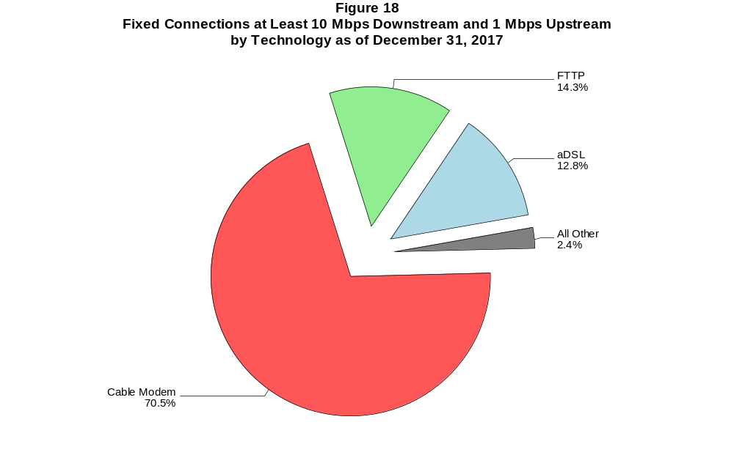

Figure 19
Residential Fixed Connections at Least 10 Mbps Downstream and 1 Mbps Upstream
by Technology 2014-2017
(In thousands)

 | 2014 |  | 2015 |  | 2016 |  | 2017
Technology | Jun* | Dec | Jun | Dec | Jun | Dec | Jun | Dec
Total | 59,729 | 63,732 | 67,898 | 71,784 | 74,840 | 78,202 | 80,671 | 84,156
aDSL | 7,025 | 7,970 | 8,743 | 9,069 | 9,526 | 9,963 | 10,415 | 10,657
sDSL | 3 | # | # | 1 | 2 | 2 | 6 | 5
Other Wireline¹ | 33 | 36 | 38 | 43 | 47 | 30 | 71 | 64
Cable Modem | 44,480 | 46,772 | 49,487 | 52,294 | 54,274 | 56,538 | 57,617 | 59,863
FTTP² | 7,032 | 7,653 | 8,144 | 8,776 | 9,248 | 10,004 | 10,835 | 11,762
Satellite | 1,014 | 1,133 | 1,293 | 1,386 | 1,460 | 1,333 | 1,362 | 1,387
Fixed Wireless | 142 | 167 | 191 | 213 | 283 | 332 | 365 | 418

¹ Power Line and Other are summarized with Other Wireline to maintain firm confidentiality. See Technical Notes at the end of the report for a description of
Form 477 technology categories and other reporting requirements.
² Fiber to the premises.
* The June 2014 data have not been subjected to the typical quality checks (see Technical Notes).
# = Rounds to zero.

The Commission approved changes to the Form 477 in June 2013 that affect the data beginning in June 2014 (see Technical Notes).
Figures may not sum to totals due to rounding.

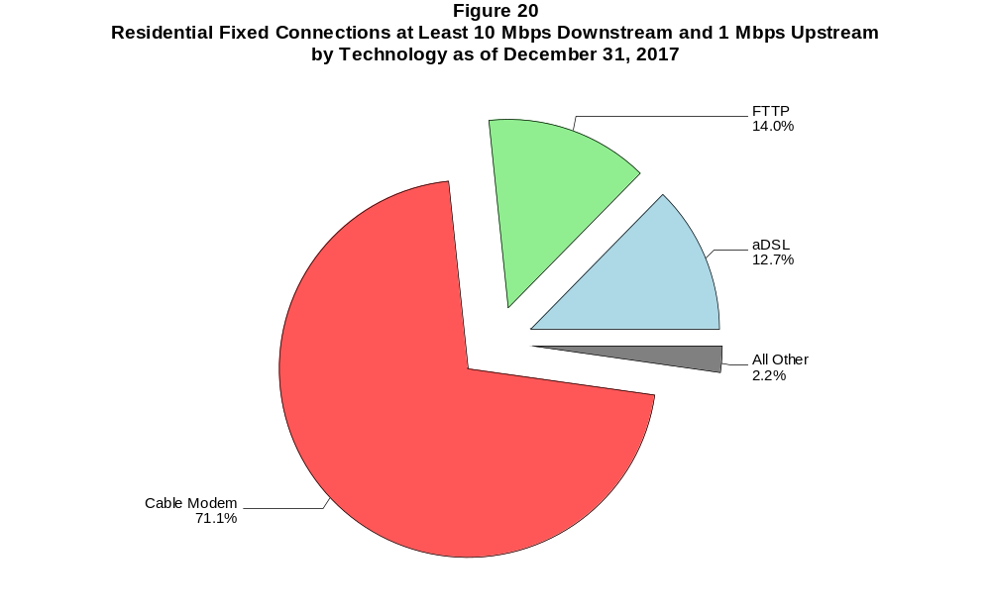

Figure 21
Fixed Connections at Least 25 Mbps Downstream and 3 Mbps Upstream by Technology 2014-2017
(In thousands)

 | 2014 |  | 2015 |  | 2016 |  | 2017
Technology | Jun+ | Dec | Jun | Dec | Jun | Dec | Jun | Dec
Total | 35,924 | 42,713 | 48,784 | 54,335 | 58,753 | 62,907 | 68,041 | 73,329
aDSL | 421 | 587 | 762 | 938 | 1,239 | 1,476 | 2,530 | 3,586
sDSL | 2 | 1 | 1 | * | * | * | * | *
Other Wireline¹ | 114 | 125 | 125 | 141 | 158 | 170 | 207 | 224
Cable Modem | 30,769 | 36,383 | 40,979 | 45,530 | 48,696 | 51,740 | 54,829 | 57,869
FTTP² | 4,600 | 5,589 | 6,871 | 7,691 | 8,608 | 9,449 | 10,374 | 11,525
Satellite | # | # | # | * | * | * | * | *
Fixed Wireless | 19 | 28 | 47 | 55 | 72 | 92 | 120 | 145

¹ Power Line and Other are summarized with Other Wireline to maintain firm confidentiality. See Technical Notes at the end of the report for a description of
Form 477 technology categories and other reporting requirements.
² Fiber to the premises.
+ The June 2014 data have not been subjected to the typical quality checks (see Technical Notes).
* = Data withheld to maintain firm confidentiality.
# = Rounds to zero.

The Commission approved changes to the Form 477 in June 2013 that affect the data beginning in June 2014 (see Technical Notes).
Figures may not sum to totals due to rounding.

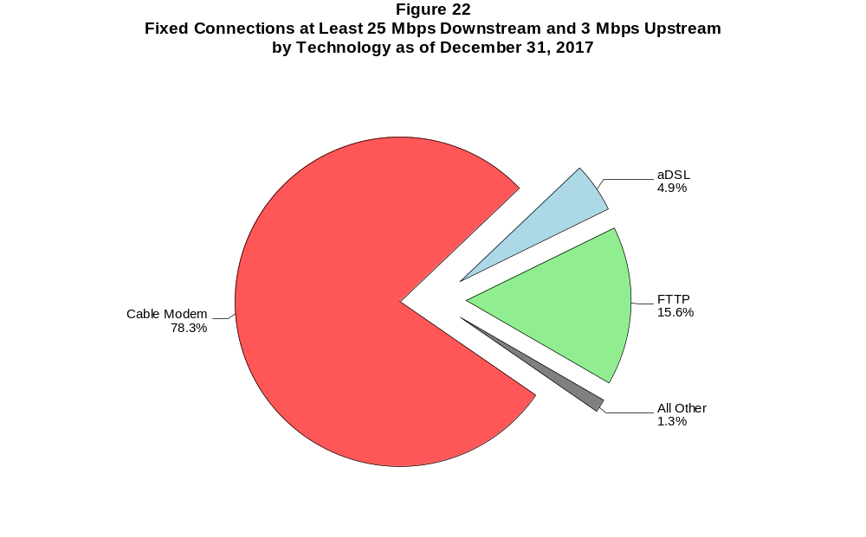

Figure 23
Residential Fixed Connections at Least 25 Mbps Downstream and 3 Mbps Upstream
by Technology 2014-2017
(In thousands)

 | 2014 |  | 2015 |  | 2016 |  | 2017
Technology | Jun+ | Dec | Jun | Dec | Jun | Dec | Jun | Dec
Total | 34,437 | 40,916 | 46,532 | 51,788 | 55,694 | 59,463 | 64,253 | 68,869
aDSL | 397 | 556 | 727 | 897 | 1,173 | 1,408 | 2,418 | 3,410
sDSL | # | # | # | * | * | * | * | *
Other Wireline¹ | 22 | 26 | 26 | 31 | 41 | 27 | 67 | 59
Cable Modem | 29,806 | 35,202 | 39,416 | 43,746 | 46,527 | 49,300 | 52,154 | 54,747
FTTP² | 4,198 | 5,111 | 6,323 | 7,089 | 7,916 | 8,674 | 9,532 | 10,553
Satellite | 0 | 0 | 0 | * | * | * | * | *
Fixed Wireless | 14 | 22 | 40 | 46 | 57 | 75 | 101 | 120

¹ Power Line and Other are summarized with Other Wireline to maintain firm confidentiality. See Technical Notes at the end of the report for a description of
Form 477 technology categories and other reporting requirements.
² Fiber to the premises.
+ The June 2014 data have not been subjected to the typical quality checks (see Technical Notes).
* = Data withheld to maintain firm confidentiality.
# = Rounds to zero.

The Commission approved changes to the Form 477 in June 2013 that affect the data beginning in June 2014 (see Technical Notes).
Figures may not sum to totals due to rounding.

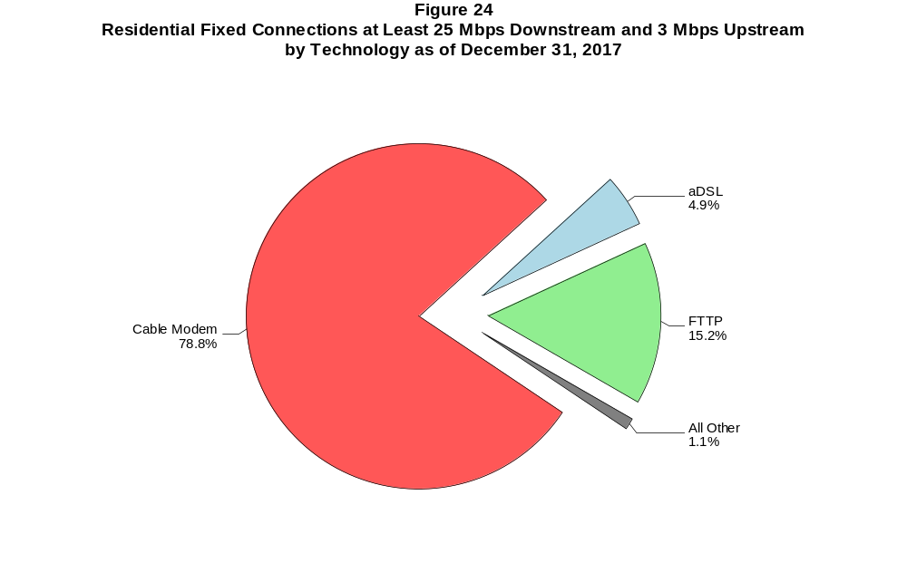

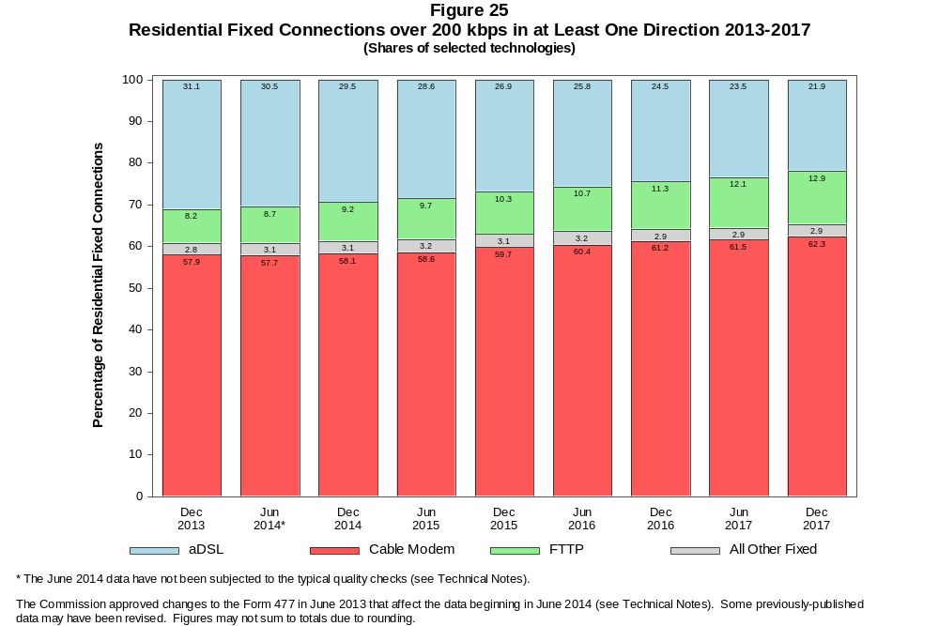

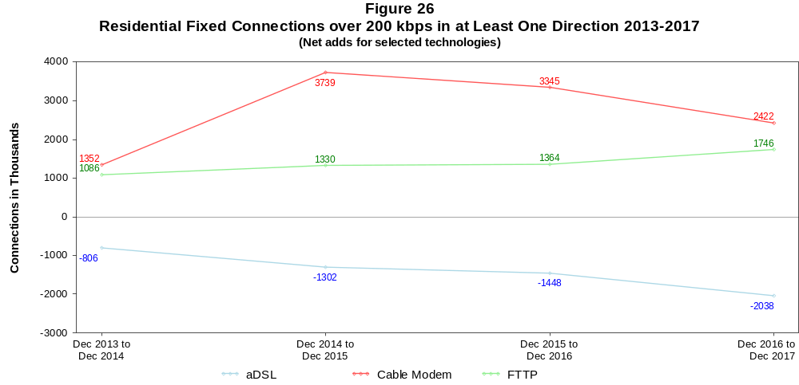

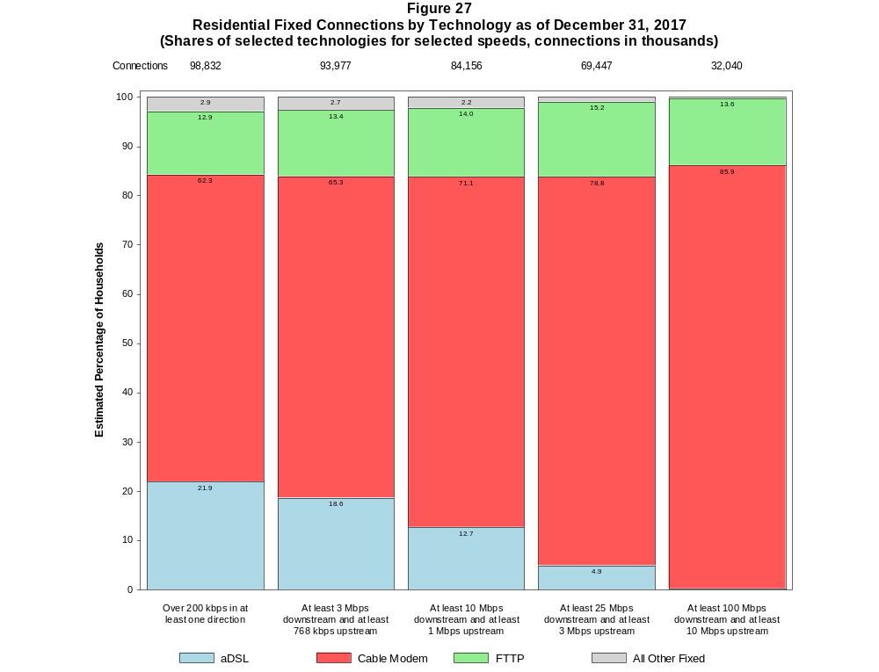

Figure 28
Fixed Connections by Downstream Speed Tier and Technology as of December 31, 2017
(In thousands)

 | Downstream Speed
Technology | Less than  1.5 Mbps | At least 1.5 Mbps  and less than  3 Mbps | At least 3 Mbps  and less than  10 Mbps | At least 10 Mbps  and less than  25 Mbps | At least 25 Mbps  and less than  100 Mbps | At least 100 Mbps | Total
aDSL | 717 | 1,376 | 8,557 | 9,513 | 3,958 | 72 | 24,193
sDSL | 6 | 6 | 7 | 6 | * | * | 28
Other Wireline¹ | 30 | 228 | 100 | 48 | 29 | 195 | 631
Cable Modem | 60 | 64 | 2,051 | 5,834 | 22,688 | 35,499 | 66,195
FTTP | 45 | 35 | 602 | 1,736 | 6,746 | 4,814 | 13,978
Satellite | 282 | 23 | 165 | 837 | * | * | 1,872
Fixed Wireless | 62 | 130 | 615 | 332 | 115 | 37 | 1,292
Total | 1,202 | 1,862 | 12,096 | 18,306 | 34,104 | 40,618 | 108,188

Percentages

aDSL | 0.7 | 1.3 | 7.9 | 8.8 | 3.7 | 0.1 | 22.4
sDSL | 0.0 | 0.0 | 0.0 | 0.0 | * | * | 0.0
Other Wireline¹ | 0.0 | 0.2 | 0.1 | 0.0 | 0.0 | 0.2 | 0.6
Cable Modem | 0.1 | 0.1 | 1.9 | 5.4 | 21.0 | 32.8 | 61.2
FTTP | 0.0 | 0.0 | 0.6 | 1.6 | 6.2 | 4.4 | 12.9
Satellite | 0.3 | 0.0 | 0.2 | 0.8 | * | * | 1.7
Fixed Wireless | 0.1 | 0.1 | 0.6 | 0.3 | 0.1 | 0.0 | 1.2
Total | 1.1 | 1.7 | 11.2 | 16.9 | 31.5 | 37.5 | 100.0

¹ Power Line and Other are summarized with Other Wireline to maintain firm confidentiality. See Technical Notes at the end of the report for a description of Form 477 technology categories
and other reporting requirements.
# = Rounds to Zero.
* = Data withheld to maintain firm confidentiality.
Note: Figures may not sum to totals due to rounding.
Source: FCC Form 477.

Figure 29
Residential Fixed Connections by Downstream Speed Tier and Technology as of December 31, 2017
(In thousands)

 | Downstream Speed
Technology | Less than  1.5 Mbps | At least 1.5 Mbps  and less than  3 Mbps | At least 3 Mbps  and less than  10 Mbps | At least 10 Mbps  and less than  25 Mbps | At least 25 Mbps  and less than  100 Mbps | At least 100 Mbps | Total
aDSL | 640 | 1,124 | 7,418 | 8,653 | 3,755 | 64 | 21,653
sDSL | 2 | 1 | 1 | 4 | * | * | 9
Other Wireline¹ | # | 1 | 3 | 5 | 6 | 53 | 68
Cable Modem | 54 | 35 | 1,573 | 4,856 | 20,561 | 34,488 | 61,567
FTTP | 34 | 26 | 543 | 1,515 | 6,207 | 4,376 | 12,702
Satellite | 133 | 8 | 160 | 830 | * | * | 1,688
Fixed Wireless | 54 | 118 | 554 | 291 | 101 | 27 | 1,146
Total | 917 | 1,313 | 10,253 | 16,155 | 31,187 | 39,007 | 98,832

Percentages

aDSL | 0.6 | 1.1 | 7.5 | 8.8 | 3.8 | 0.1 | 21.9
sDSL | 0.0 | 0.0 | 0.0 | 0.0 | * | * | 0.0
Other Wireline¹ | 0.0 | 0.0 | 0.0 | 0.0 | 0.0 | 0.1 | 0.1
Cable Modem | 0.1 | 0.0 | 1.6 | 4.9 | 20.8 | 34.9 | 62.3
FTTP | 0.0 | 0.0 | 0.5 | 1.5 | 6.3 | 4.4 | 12.9
Satellite | 0.1 | 0.0 | 0.2 | 0.8 | * | * | 1.7
Fixed Wireless | 0.1 | 0.1 | 0.6 | 0.3 | 0.1 | 0.0 | 1.2
Total | 0.9 | 1.3 | 10.4 | 16.3 | 31.6 | 39.5 | 100.0

¹ Power Line and Other are summarized with Other Wireline to maintain firm confidentiality. See Technical Notes at the end of the report for a description of Form 477 technology categories
and other reporting requirements.
# = Rounds to Zero.
* = Data withheld to maintain firm confidentiality.
Note: Figures may not sum to totals due to rounding.
Source: FCC Form 477.

Figure 30
Nationwide Number of Providers of Connections over 200 kbps in at Least One Direction
by Technology 2013-2017

 | 2013 | 2014 |  | 2015 |  | 2016 |  | 2017
Technology | Dec | Jun+ | Dec | Jun | Dec | Jun | Dec | Jun | Dec
aDSL | 851 | 793 | 793 | 792 | 778 | 769 | 774 | 769 | 742
sDSL | 239 | 192 | 187 | 177 | 180 | 171 | 161 | 161 | 151
Other Wireline¹ | 245 | 270 | 245 | 240 | 250 | 244 | 236 | 243 | 236
Cable Modem | 407 | 394 | 402 | 393 | 392 | 388 | 385 | 383 | 382
FTTP | 744 | 879 | 910 | 931 | 990 | 1,016 | 1,067 | 1,103 | 1,148
Satellite | 5 | 16 | 14 | 10 | 10 | 6 | 6 | 5 | 6
Fixed Wireless | 825 | 872 | 922 | 948 | 982 | 1,025 | 1,068 | 1,093 | 1,153
Mobile Wireless | 77 | 91 | 98 | 100 | 96 | 99 | 97 | 97 | 83
Power Line and Other¹ | * | - | - | - | - | - | - | - | -
Total | 1,773 | 1,816 | 1,872 | 1,881 | 1,917 | 1,955 | 1,999 | 2,028 | 2,083

¹ For this Figure, the categories Power Line and All Other were combined with Other Wireline from June 2014 forward.
+ The June 2014 data have not been subjected to the typical quality checks (see Technical Notes).
Multiple Form 477 filers within a holding company structure count as one provider. * = 1-3 providers.

The Commission approved changes to the Form 477 in June 2013 that affect the data beginning in June 2014 (see Technical Notes). Some previously-published
data may have been revised.

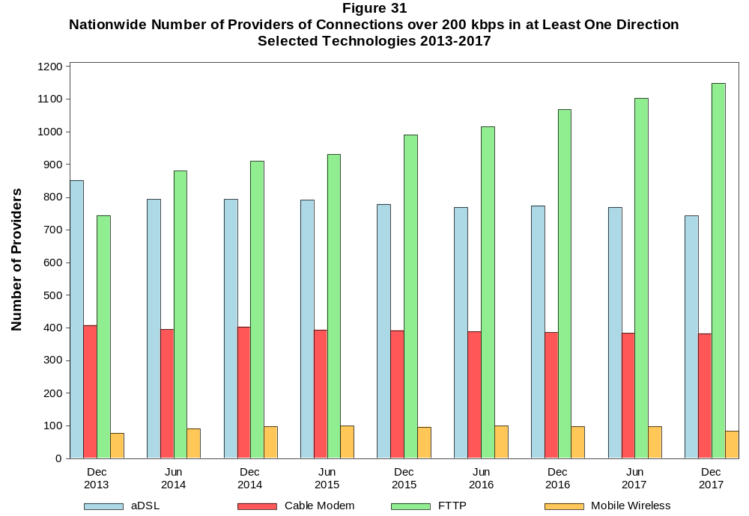

Figure 32
Residential Fixed Connections and Households by State as of December 31, 2017
(Connections and households, in thousands)

 |  | At least 200 kbps in  at least One Direction |  | At least 10 Mbps Down  and 1 Mbps Up |  | At least 25 Mbps Down  and 3 Mbps Up |  | At least 100 Mbps Down  and 10 Mbps Up
State | Households | Connections | Subscribership  Ratio | Connections | Subscribership  Ratio | Connections | Subscribership  Ratio | Connections | Subscribership  Ratio
Alabama | 1,857 | 1,331 | 0.72 | 1,050 | 0.57 | 791 | 0.43 | 266 | 0.14
Alaska | 253 | 201 | 0.79 | 158 | 0.63 | * | * | * | *
American Samoa | 10 | * | * | 0 | 0.00 | 0 | 0.00 | 0 | 0.00
Arizona | 2,482 | 2,116 | 0.85 | 1,667 | 0.67 | 1,361 | 0.55 | 655 | 0.26
Arkansas | 1,147 | 770 | 0.67 | 562 | 0.49 | 362 | 0.32 | 112 | 0.10
California | 12,888 | 11,251 | 0.87 | 9,977 | 0.77 | 8,215 | 0.64 | 4,175 | 0.32
Colorado | 2,083 | 1,864 | 0.90 | 1,487 | 0.71 | 1,362 | 0.65 | 534 | 0.26
Connecticut | 1,362 | 1,201 | 0.88 | 1,080 | 0.79 | 882 | 0.65 | 423 | 0.31
Delaware | 352 | 327 | 0.93 | 311 | 0.88 | 300 | 0.85 | 116 | 0.33
District of Columbia | 278 | 242 | 0.87 | 224 | 0.81 | 213 | 0.77 | * | *
Florida | 7,511 | 7,134 | 0.95 | 6,395 | 0.85 | 5,319 | 0.71 | 2,654 | 0.35
Georgia | 3,663 | 2,983 | 0.81 | 2,493 | 0.68 | 1,942 | 0.53 | 733 | 0.20
Guam | 42 | * | * | * | * | * | * | 0 | 0.00
Hawaii | 456 | 423 | 0.93 | 418 | 0.92 | * | * | * | *
Idaho | 609 | 495 | 0.81 | 302 | 0.50 | 236 | 0.39 | 48 | 0.08
Illinois | 4,818 | 3,834 | 0.80 | 3,328 | 0.69 | 2,630 | 0.55 | 904 | 0.19
Indiana | 2,537 | 1,934 | 0.76 | 1,572 | 0.62 | 1,195 | 0.47 | 525 | 0.21
Iowa | 1,252 | 935 | 0.75 | 658 | 0.53 | 544 | 0.43 | 181 | 0.14
Kansas | 1,122 | 883 | 0.79 | 696 | 0.62 | 489 | 0.44 | 255 | 0.23
Kentucky | 1,725 | 1,272 | 0.74 | 958 | 0.56 | 673 | 0.39 | 449 | 0.26
Louisiana | 1,738 | 1,256 | 0.72 | 1,031 | 0.59 | 742 | 0.43 | 266 | 0.15
Maine | 554 | 484 | 0.87 | 367 | 0.66 | 243 | 0.44 | 138 | 0.25
Maryland | 2,181 | 1,897 | 0.87 | 1,787 | 0.82 | 1,678 | 0.77 | 659 | 0.30
Massachusetts | 2,586 | 2,334 | 0.90 | 2,195 | 0.85 | 2,113 | 0.82 | 857 | 0.33
Michigan | 3,889 | 3,021 | 0.78 | 2,610 | 0.67 | 2,108 | 0.54 | 602 | 0.15
Minnesota | 2,153 | 1,740 | 0.81 | 1,344 | 0.62 | 1,177 | 0.55 | 318 | 0.15
Mississippi | 1,104 | 675 | 0.61 | 500 | 0.45 | 310 | 0.28 | 78 | 0.07
Missouri | 2,386 | 1,801 | 0.75 | 1,388 | 0.58 | 1,042 | 0.44 | 415 | 0.17
Montana | 420 | 337 | 0.80 | 239 | 0.57 | 204 | 0.49 | 50 | 0.12
Nebraska | 748 | 579 | 0.77 | 445 | 0.59 | 342 | 0.46 | 173 | 0.23

Figure 32 - Continued
Residential Fixed Connections and Households by State as of December 31, 2017
(Connections and households, in thousands)

 |  | At least 200 kbps in  at least One Direction |  | At least 10 Mbps Down  and 1 Mbps Up |  | At least 25 Mbps Down  and 3 Mbps Up |  | At least 100 Mbps Down  and 10 Mbps Up
State | Households | Connections | Subscribership  Ratio | Connections | Subscribership  Ratio | Connections | Subscribership  Ratio | Connections | Subscribership  Ratio
Nevada | 1,052 | 909 | 0.86 | 778 | 0.74 | 612 | 0.58 | * | *
New Hampshire | 527 | 471 | 0.90 | 409 | 0.78 | 369 | 0.70 | 166 | 0.31
New Jersey | 3,199 | 2,942 | 0.92 | 2,805 | 0.88 | 2,712 | 0.85 | 1,394 | 0.44
New Mexico | 770 | 557 | 0.72 | 358 | 0.46 | 305 | 0.40 | 81 | 0.11
New York | 7,303 | 6,244 | 0.85 | 5,842 | 0.80 | 5,282 | 0.72 | 3,287 | 0.45
North Carolina | 3,874 | 3,248 | 0.84 | 2,629 | 0.68 | 2,273 | 0.59 | 1,456 | 0.38
North Dakota | 312 | 250 | 0.80 | 223 | 0.72 | 194 | 0.62 | 51 | 0.16
Northern Mariana Isl | 16 | * | * | * | * | * | * | 0 | 0.00
Ohio | 4,633 | 3,673 | 0.79 | 3,066 | 0.66 | 2,153 | 0.46 | 1,224 | 0.26
Oklahoma | 1,469 | 1,025 | 0.70 | 770 | 0.52 | 519 | 0.35 | 211 | 0.14
Oregon | 1,572 | 1,320 | 0.84 | 1,087 | 0.69 | 965 | 0.61 | 351 | 0.22
Pennsylvania | 5,007 | 4,073 | 0.81 | 3,552 | 0.71 | 3,155 | 0.63 | 1,331 | 0.27
Puerto Rico | 1,223 | * | * | 293 | 0.24 | * | * | * | *
Rhode Island | 412 | 358 | 0.87 | 345 | 0.84 | 311 | 0.76 | * | *
South Carolina | 1,871 | 1,511 | 0.81 | 1,278 | 0.68 | 892 | 0.48 | 276 | 0.15
South Dakota | 339 | 261 | 0.77 | 230 | 0.68 | 204 | 0.60 | 26 | 0.08
Tennessee | 2,547 | 1,911 | 0.75 | 1,643 | 0.65 | 1,303 | 0.51 | 541 | 0.21
Texas | 9,430 | 7,513 | 0.80 | 6,460 | 0.68 | 4,959 | 0.53 | 2,698 | 0.29
Utah | 938 | 822 | 0.88 | 653 | 0.70 | 573 | 0.61 | 221 | 0.24
Vermont | 259 | 232 | 0.90 | 176 | 0.68 | 141 | 0.55 | 56 | 0.22
Virgin Islands | 43 | * | * | * | * | * | * | * | *
Virginia | 3,106 | 2,568 | 0.83 | 2,261 | 0.73 | 2,036 | 0.66 | 887 | 0.29
Washington | 2,756 | 2,415 | 0.88 | 2,025 | 0.73 | 1,848 | 0.67 | 802 | 0.29
West Virginia | 738 | 537 | 0.73 | 390 | 0.53 | 312 | 0.42 | 142 | 0.19
Wisconsin | 2,329 | 1,808 | 0.78 | 1,459 | 0.63 | 1,061 | 0.46 | 371 | 0.16
Wyoming | 230 | 179 | 0.78 | 135 | 0.58 | 111 | 0.48 | 17 | 0.07
Total | 120,159 | 98,832 | 0.82 | 84,156 | 0.70 | 69,447 | 0.58 | 32,040 | 0.27

# = Rounds to Zero; * = Data withheld to maintain firm confidentiality.
Note: Figures may not sum to totals due to rounding.
Sources: FCC Form 477 (Connections); 2013-2017 ACS 5-year estimates; Census 2010.

Figure 33
Connections by Type of End User by State as of December 31, 2017
(Connections over 200 kbps in at least one direction, in thousands)

 | Connections |  | Percentages
State | Residential | Business | Residential | Business | Total
Alabama | 5,466 | 642 | 89.5 | 10.5 | 6,108
Alaska | 839 | 120 | 87.4 | 12.6 | 959
American Samoa | * | * | * | * | *
Arizona | 7,195 | 1,017 | 87.6 | 12.4 | 8,211
Arkansas | 3,134 | 425 | 88.1 | 11.9 | 3,559
California | 44,440 | 8,113 | 84.6 | 15.4 | 52,552
Colorado | 6,252 | 919 | 87.2 | 12.8 | 7,171
Connecticut | 4,114 | 732 | 84.9 | 15.1 | 4,847
Delaware | 1,089 | 140 | 88.6 | 11.4 | 1,229
District of Columbia | 989 | 444 | 69.0 | 31.0 | 1,433
Florida | 23,940 | 3,900 | 86.0 | 14.0 | 27,840
Georgia | 11,605 | 1,633 | 87.7 | 12.3 | 13,238
Guam | 180 | 55 | 76.7 | 23.3 | 235
Hawaii | 1,716 | 207 | 89.2 | 10.8 | 1,923
Idaho | 1,766 | 237 | 88.2 | 11.8 | 2,003
Illinois | 14,323 | 2,324 | 86.0 | 14.0 | 16,647
Indiana | 7,015 | 908 | 88.5 | 11.5 | 7,923
Iowa | 3,302 | 520 | 86.4 | 13.6 | 3,822
Kansas | 4,420 | 483 | 90.1 | 9.9 | 4,903
Kentucky | 4,938 | 590 | 89.3 | 10.7 | 5,529
Louisiana | 5,147 | 671 | 88.5 | 11.5 | 5,818
Maine | 1,542 | 213 | 87.9 | 12.1 | 1,754
Maryland | 6,970 | 998 | 87.5 | 12.5 | 7,968
Massachusetts | 8,282 | 1,258 | 86.8 | 13.2 | 9,540
Michigan | 10,863 | 1,698 | 86.5 | 13.5 | 12,561
Minnesota | 6,116 | 968 | 86.3 | 13.7 | 7,084
Mississippi | 3,138 | 327 | 90.6 | 9.4 | 3,465
Missouri | 6,494 | 1,003 | 86.6 | 13.4 | 7,497
Montana | 1,165 | 135 | 89.6 | 10.4 | 1,300
Nebraska | 1,978 | 354 | 84.8 | 15.2 | 2,332
Nevada | 3,321 | 402 | 89.2 | 10.8 | 3,723
New Hampshire | 1,545 | 215 | 87.8 | 12.2 | 1,760
New Jersey | 10,441 | 1,714 | 85.9 | 14.1 | 12,154
New Mexico | 2,126 | 244 | 89.7 | 10.3 | 2,370
New York | 23,781 | 3,733 | 86.4 | 13.6 | 27,513
North Carolina | 11,025 | 1,569 | 87.5 | 12.5 | 12,594
North Dakota | 858 | 129 | 87.0 | 13.0 | 986
Northern Mariana Isl | * | * | * | * | *
Ohio | 12,941 | 1,805 | 87.8 | 12.2 | 14,747
Oklahoma | 3,997 | 584 | 87.2 | 12.8 | 4,581
Oregon | 4,597 | 679 | 87.1 | 12.9 | 5,276
Pennsylvania | 14,337 | 2,007 | 87.7 | 12.3 | 16,344
Puerto Rico | 3,510 | 269 | 92.9 | 7.1 | 3,778
Rhode Island | 1,125 | 178 | 86.3 | 13.7 | 1,303
South Carolina | 5,309 | 652 | 89.1 | 10.9 | 5,961
South Dakota | 949 | 111 | 89.5 | 10.5 | 1,060
Tennessee | 7,328 | 993 | 88.1 | 11.9 | 8,321
Texas | 29,795 | 5,024 | 85.6 | 14.4 | 34,819
Utah | 3,047 | 474 | 86.5 | 13.5 | 3,521
Vermont | 715 | 110 | 86.7 | 13.3 | 824
Virgin Islands | 127 | 12 | 91.5 | 8.5 | 139
Virginia | 8,908 | 1,516 | 85.5 | 14.5 | 10,423
Washington | 8,438 | 1,241 | 87.2 | 12.8 | 9,679
West Virginia | 1,689 | 195 | 89.7 | 10.3 | 1,884
Wisconsin | 5,975 | 956 | 86.2 | 13.8 | 6,931
Wyoming | 683 | 74 | 90.2 | 9.8 | 757
Total | 365,040 | 55,926 | 86.7 | 13.3 | 420,966

# = Rounds to Zero.
* = Data withheld to maintain firm confidentiality.
Figures may not sum to totals due to rounding.
Source: FCC Form 477.

Figure 34
Connections by Technology by State as of December 31, 2017
(Connections over 200 kbps in at least one direction, in thousands)

State | ADSL | SDSL | Other  Wireline¹ | Cable  Modem | Fiber | Satellite | Fixed  Wireless | Mobile  Wireless | Total
Alabama | 506 | # | * | 784 | 100 | * | 6 | 4,647 | 6,108
Alaska | 77 | # | 2 | * | 5 | * | 8 | 727 | 959
American Samoa | * | * | 0 | * | * | 0 | * | * | *
Arizona | 541 | # | * | 1,509 | 150 | * | 37 | 5,931 | 8,211
Arkansas | 346 | # | * | 410 | 33 | * | 7 | 2,712 | 3,559
California | 3,127 | 3 | * | 7,831 | 1,049 | * | 99 | 40,211 | 52,552
Colorado | * | # | 19 | 1,256 | 227 | * | 62 | 5,134 | 7,171
Connecticut | * | # | 4 | 979 | 12 | * | # | 3,528 | 4,847
Delaware | * | * | 3 | 220 | * | * | # | 874 | 1,229
District of Columbia | * | * | 5 | * | * | * | 2 | 1,156 | 1,433
Florida | 1,611 | # | * | 5,190 | 834 | * | 13 | 20,071 | 27,840
Georgia | 990 | # | * | 1,853 | 350 | * | 4 | 9,956 | 13,238
Guam | * | 0 | * | * | * | 0 | 0 | 190 | 235
Hawaii | * | 2 | 1 | * | * | * | 2 | 1,463 | 1,923
Idaho | 167 | # | * | 219 | 87 | * | 48 | 1,463 | 2,003
Illinois | 1,176 | 1 | * | 2,700 | 183 | * | 74 | 12,438 | 16,647
Indiana | 645 | # | * | 1,138 | 221 | * | 40 | 5,823 | 7,923
Iowa | 283 | 1 | * | 477 | 189 | * | 42 | 2,798 | 3,822
Kansas | 248 | # | * | 472 | 181 | * | 40 | 3,940 | 4,903
Kentucky | 424 | # | * | 764 | 138 | * | 16 | 4,144 | 5,529
Louisiana | 410 | * | 6 | 808 | 101 | * | 6 | 4,431 | 5,818
Maine | 125 | 1 | * | 382 | 12 | * | 4 | 1,217 | 1,754
Maryland | * | # | 16 | 1,089 | * | * | 6 | 5,905 | 7,968
Massachusetts | * | # | 21 | 1,880 | * | * | 5 | 6,981 | 9,540
Michigan | 841 | 2 | * | 2,229 | 68 | * | 46 | 9,273 | 12,561
Minnesota | 484 | 2 | * | 1,118 | 220 | * | 30 | 5,190 | 7,084
Mississippi | 340 | # | * | 322 | 32 | * | 2 | 2,712 | 3,465
Missouri | 679 | # | * | 917 | 241 | * | 43 | 5,536 | 7,497
Montana | 100 | # | * | 204 | 32 | * | 26 | 922 | 1,300
Nebraska | 146 | # | * | 394 | 60 | * | 26 | 1,695 | 2,332

Figure 34 - Continued
Connections by Technology by State as of December 31, 2017
(Connections over 200 kbps in at least one direction, in thousands)

State | ADSL | SDSL | Other  Wireline¹ | Cable  Modem | Fiber | Satellite | Fixed  Wireless | Mobile  Wireless | Total
Nevada | 219 | # | 6 | * | 24 | * | 18 | 2,730 | 3,723
New Hampshire | 74 | # | * | 412 | 29 | * | 1 | 1,235 | 1,760
New Jersey | 160 | # | 27 | 2,076 | * | * | 1 | 8,907 | 12,154
New Mexico | 234 | # | * | 294 | 43 | * | 23 | 1,759 | 2,370
New York | 410 | # | 38 | 4,798 | * | * | 8 | 20,624 | 27,513
North Carolina | 842 | # | * | 2,278 | 329 | * | 7 | 9,060 | 12,594
North Dakota | 42 | # | * | 149 | 84 | * | 4 | 704 | 986
Northern Mariana Isl | * | * | 0 | * | * | 0 | * | * | *
Ohio | 1,062 | # | * | 2,565 | 242 | * | 44 | 10,772 | 14,747
Oklahoma | 375 | # | * | 582 | 74 | * | 48 | 3,449 | 4,581
Oregon | 247 | # | * | 940 | 192 | * | 25 | 3,831 | 5,276
Pennsylvania | 569 | # | 28 | 2,832 | * | * | 7 | 11,905 | 16,344
Puerto Rico | * | 0 | * | * | 7 | * | 8 | 3,100 | 3,778
Rhode Island | * | * | 2 | * | * | * | * | 912 | 1,303
South Carolina | 453 | # | * | 998 | 144 | * | 4 | 4,319 | 5,961
South Dakota | 45 | * | # | 169 | 58 | * | 10 | 772 | 1,060
Tennessee | 542 | # | * | 1,176 | 302 | * | 11 | 6,223 | 8,321
Texas | 2,291 | 1 | * | 4,272 | 1,224 | * | 205 | 26,592 | 34,819
Utah | 168 | # | * | 492 | 175 | * | 48 | 2,627 | 3,521
Vermont | 88 | # | * | 144 | 25 | * | 1 | 559 | 824
Virgin Islands | * | 0 | * | * | * | * | * | * | 139
Virginia | 300 | # | * | 1,480 | 908 | * | 19 | 7,607 | 10,423
Washington | 432 | # | * | 1,839 | 246 | * | 35 | 7,050 | 9,679
West Virginia | * | * | 1 | 362 | 11 | * | 2 | 1,296 | 1,884
Wisconsin | 617 | 8 | 5 | * | 109 | * | 40 | 4,960 | 6,931
Wyoming | 50 | # | * | 110 | 12 | * | 22 | 555 | 757
Total | 24,193 | 28 | 631 | 66,195 | 13,978 | 1,872 | 1,292 | 312,778 | 420,966

¹ PowerLine and Other are summarized with Other Wireline to maintain firm confidentiality. See Technical Notes at the end of the report for a description of Form 477 technology categories and
other reporting requirements.
# = Rounds to Zero.
* = Data withheld to maintain firm confidentiality.
Figures may not sum to totals due to rounding.
Source: FCC Form 477.

Figure 35
Percentage of Fixed Connections by Downstream Speed by State as of December 31, 2017

 | Over 200 kbps Upstream and
State | % over 200 kbps  Downstream | % at least 3 Mbps  Downstream | % at least 10 Mbps  Downstream | % at least 25 Mbps  Downstream | % at least 100 Mbps  Downstream
Alabama | 99.5 | 94.9 | 80.6 | 59.3 | 21.6
Alaska | 98.4 | 92.0 | 78.3 | 58.6 | 41.9
American Samoa | * | * | * | * | *
Arizona | 99.8 | 97.4 | 87.5 | 64.1 | 34.2
Arkansas | 99.5 | 94.2 | 76.2 | 48.7 | 16.9
California | 99.7 | 97.8 | 87.0 | 70.8 | 44.2
Colorado | 99.8 | 96.4 | 88.7 | 71.6 | 45.4
Connecticut | 99.5 | 99.2 | 88.2 | 71.5 | 45.3
Delaware | 99.9 | 98.7 | 93.3 | 88.9 | 53.4
District of Columbia | 99.9 | 98.0 | 89.7 | 84.1 | 57.1
Florida | 99.7 | 98.1 | 91.2 | 74.0 | 35.8
Georgia | 99.3 | 96.5 | 83.5 | 64.2 | 26.2
Guam | * | * | * | * | *
Hawaii | 100.0 | 99.7 | 97.8 | 88.8 | 54.3
Idaho | 99.6 | 95.3 | 75.0 | 48.1 | 32.5
Illinois | 99.8 | 97.7 | 85.7 | 66.9 | 25.6
Indiana | 99.5 | 97.2 | 81.9 | 60.7 | 26.0
Iowa | 99.7 | 94.4 | 77.8 | 56.8 | 20.8
Kansas | 99.7 | 95.8 | 79.6 | 53.6 | 28.5
Kentucky | 99.2 | 95.1 | 75.9 | 52.8 | 33.6
Louisiana | 99.4 | 95.4 | 82.1 | 58.8 | 23.0
Maine | 99.1 | 95.4 | 74.6 | 49.2 | 28.8
Maryland | 99.9 | 98.5 | 92.3 | 86.1 | 48.8
Massachusetts | 99.9 | 98.6 | 92.1 | 87.4 | 54.9
Michigan | 99.5 | 97.3 | 85.3 | 68.4 | 20.5
Minnesota | 99.8 | 96.2 | 84.3 | 66.8 | 31.1
Mississippi | 99.2 | 93.0 | 74.3 | 47.1 | 20.1
Missouri | 99.6 | 95.4 | 80.8 | 58.1 | 40.4
Montana | 99.7 | 93.1 | 76.6 | 60.7 | 14.9
Nebraska | 99.7 | 96.7 | 80.3 | 58.5 | 29.5

Figure 35 - Continued
Percentage of Fixed Connections by Downstream Speed by State as of December 31, 2017

 | Over 200 kbps Upstream and
State | % over 200 kbps  Downstream | % at least 3 Mbps  Downstream | % at least 10 Mbps  Downstream | % at least 25 Mbps  Downstream | % at least 100 Mbps  Downstream
Nevada | 99.9 | 98.4 | 89.6 | 68.8 | 30.8
New Hampshire | 99.2 | 96.6 | 84.5 | 75.0 | 51.7
New Jersey | 99.8 | 98.7 | 94.3 | 90.1 | 56.1
New Mexico | 99.8 | 93.9 | 77.6 | 54.5 | 30.7
New York | 99.7 | 98.7 | 92.2 | 82.9 | 50.0
North Carolina | 99.4 | 96.8 | 84.0 | 68.7 | 43.4
North Dakota | 99.9 | 97.6 | 90.2 | 77.6 | 25.3
Northern Mariana Isl | * | * | * | * | *
Ohio | 99.8 | 97.3 | 83.3 | 57.9 | 32.5
Oklahoma | 99.7 | 96.6 | 75.6 | 50.1 | 23.2
Oregon | 99.8 | 96.6 | 87.0 | 72.2 | 40.4
Pennsylvania | 99.8 | 97.3 | 87.0 | 76.2 | 46.1
Puerto Rico | 99.9 | 84.7 | 51.8 | 30.5 | 3.8
Rhode Island | 99.6 | 98.8 | 95.3 | 85.5 | 40.9
South Carolina | 99.6 | 96.8 | 84.8 | 60.0 | 22.2
South Dakota | 99.7 | 97.5 | 89.6 | 77.8 | 10.7
Tennessee | 99.5 | 96.8 | 85.8 | 67.4 | 28.9
Texas | 99.8 | 97.6 | 85.5 | 64.7 | 39.4
Utah | 99.9 | 97.6 | 86.9 | 69.1 | 43.3
Vermont | 98.8 | 93.9 | 73.3 | 58.3 | 39.1
Virgin Islands | 99.8 | 85.7 | 53.8 | * | *
Virginia | 99.5 | 97.2 | 87.8 | 77.0 | 42.0
Washington | 99.6 | 96.9 | 88.1 | 74.9 | 52.6
West Virginia | 99.1 | 97.4 | 71.4 | 56.9 | 34.3
Wisconsin | 99.2 | 95.9 | 82.8 | 58.3 | 22.5
Wyoming | 99.7 | 94.0 | 80.5 | 61.3 | 9.5
Total | 99.7 | 97.2 | 86.0 | 69.1 | 37.5

Figure 36
Providers of Connections by Technology by State as of December 31, 2017
(Connections over 200 kbps in at least one direction, in thousands)

State | ADSL | SDSL | Other  Wireline¹ | Cable  Modem | Fiber | Satellite | Fixed  Wireless | Mobile  Wireless | Total
Alabama | 26 | 6 | * | 19 | 42 | * | 29 | 6 | 93
Alaska | 13 | 4 | 12 | * | 9 | * | 17 | 7 | 40
American Samoa | * | * | 0 | * | * | 0 | * | * | *
Arizona | 24 | 4 | * | 16 | 39 | * | 44 | 7 | 109
Arkansas | 26 | 5 | * | 20 | 38 | * | 23 | 5 | 83
California | 35 | 16 | * | 33 | 82 | * | 110 | 6 | 203
Colorado | * | 7 | 28 | 17 | 59 | * | 63 | 9 | 137
Connecticut | * | 5 | 16 | 10 | 23 | * | 7 | 4 | 44
Delaware | * | * | 11 | 6 | * | * | 4 | 4 | 28
District of Columbia | * | * | 12 | * | * | * | 7 | 4 | 39
Florida | 23 | 9 | * | 24 | 69 | * | 36 | 5 | 118
Georgia | 26 | 5 | * | 31 | 85 | * | 28 | 4 | 130
Guam | * | 0 | * | * | * | 0 | 0 | 4 | 4
Hawaii | * | 4 | 7 | * | * | * | 5 | 5 | 24
Idaho | 23 | 5 | * | 18 | 34 | * | 40 | 10 | 77
Illinois | 52 | 8 | * | 20 | 96 | * | 90 | 7 | 196
Indiana | 37 | 6 | * | 13 | 61 | * | 59 | 5 | 118
Iowa | 98 | 17 | * | 42 | 150 | * | 94 | 22 | 240
Kansas | 27 | 8 | * | 28 | 62 | * | 50 | 9 | 111
Kentucky | 19 | 4 | * | 28 | 44 | * | 33 | 8 | 102
Louisiana | 17 | * | 22 | 19 | 37 | * | 16 | 5 | 70
Maine | 13 | 6 | * | 9 | 20 | * | 12 | 5 | 41
Maryland | * | 5 | 18 | 19 | * | * | 25 | 5 | 78
Massachusetts | * | 4 | 21 | 11 | * | * | 24 | 5 | 69
Michigan | 35 | 10 | * | 25 | 63 | * | 46 | 6 | 129
Minnesota | 45 | 8 | * | 22 | 77 | * | 47 | 5 | 124
Mississippi | 17 | 4 | * | 14 | 26 | * | 11 | 5 | 57
Missouri | 39 | 10 | * | 18 | 62 | * | 70 | 8 | 146
Montana | 21 | 5 | * | 7 | 30 | * | 31 | 7 | 67
Nebraska | 31 | 4 | * | 20 | 54 | * | 44 | 8 | 101

Figure 36 - Continued
Providers of Connections by Technology by State as of December 31, 2017
(Connections over 200 kbps in at least one direction, in thousands)

State | ADSL | SDSL | Other  Wireline¹ | Cable  Modem | Fiber | Satellite | Fixed  Wireless | Mobile  Wireless | Total
Nevada | 17 | 7 | 21 | * | 34 | * | 24 | 5 | 74
New Hampshire | 9 | 6 | * | 5 | 20 | * | 7 | 6 | 37
New Jersey | 13 | 4 | 32 | 12 | * | * | 15 | 4 | 72
New Mexico | 19 | 5 | * | 10 | 30 | * | 31 | 8 | 73
New York | 35 | 6 | 31 | 21 | * | * | 35 | 7 | 121
North Carolina | 22 | 7 | * | 26 | 55 | * | 22 | 6 | 99
North Dakota | 24 | 7 | * | 9 | 31 | * | 15 | 6 | 48
Northern Mariana Isl | * | * | 0 | * | * | 0 | * | * | *
Ohio | 35 | 5 | * | 33 | 66 | * | 59 | 4 | 145
Oklahoma | 39 | 8 | * | 15 | 50 | * | 47 | 12 | 112
Oregon | 40 | 10 | * | 16 | 55 | * | 45 | 6 | 103
Pennsylvania | 25 | 6 | 29 | 26 | * | * | 31 | 8 | 114
Puerto Rico | * | 0 | * | * | 7 | * | 6 | 5 | 17
Rhode Island | * | * | 9 | * | * | * | * | 4 | 22
South Carolina | 19 | 4 | * | 17 | 32 | * | 14 | 6 | 57
South Dakota | 23 | * | 13 | 8 | 31 | * | 19 | 8 | 72
Tennessee | 22 | 5 | * | 22 | 54 | * | 29 | 7 | 103
Texas | 63 | 19 | * | 35 | 121 | * | 150 | 9 | 259
Utah | 20 | 4 | * | 12 | 30 | * | 32 | 9 | 73
Vermont | 12 | 4 | * | 6 | 20 | * | 6 | 6 | 36
Virgin Islands | * | 0 | * | * | * | * | * | * | 7
Virginia | 23 | 7 | * | 17 | 64 | * | 39 | 6 | 111
Washington | 26 | 7 | * | 23 | 62 | * | 55 | 6 | 123
West Virginia | * | * | 11 | 16 | 21 | * | 15 | 6 | 56
Wisconsin | 47 | 7 | 25 | * | 66 | * | 49 | 6 | 127
Wyoming | 16 | 5 | * | 5 | 17 | * | 26 | 8 | 49
Total | 742 | 151 | 236 | 382 | 1,148 | 6 | 1,153 | 83 | 2,083

¹ Power Line and Other are summarized with Other Wireline. See Technical Notes at the end of the report for a description of Form 477 technology categories and other reporting requirements.
# = Rounds to Zero.
* = Data withheld to maintain firm confidentiality.
Figures may not sum to totals due to rounding.
Source: FCC Form 477.
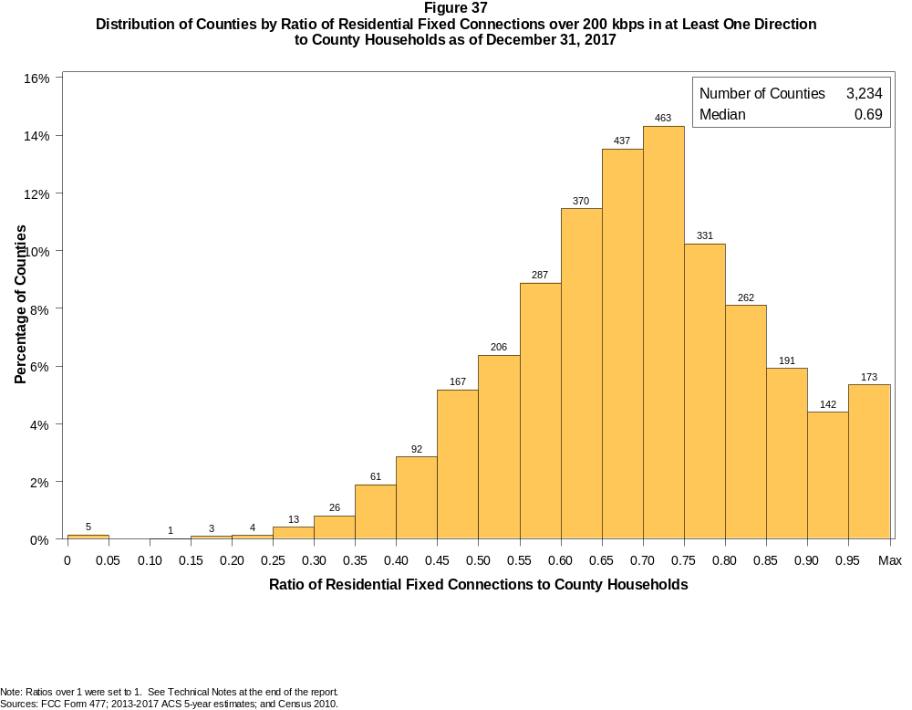

Figure 38
Distribution of Counties by Ratio of Residential Fixed Connections over 200 kbps in at Least One Direction
to County Households by Technology as of December 31, 2017

 | Ratio of Residential Fixed Connections to County Households
Technology | Zero | Greater than 0 and no more than 5% | Greater than 5 and no more than 10% | Greater than 10 and no more than 20% | Greater than 20 and no more than 30% | Greater than 30 and no more than 40% | Greater than 40 and no more than 50% | Greater than 50 and no more than 60% | Greater than 60 and no more than 80% | Greater than 80 and no more than 100% | 100% or more
aDSL | 1.2 | 5.9 | 7.6 | 27.4 | 29.9 | 16.0 | 7.6 | 2.6 | 1.4 | 0.2 | 0.2
sDSL | 93.2 | 6.6 | 0.1 | 0.0 | 0.0 | 0.0 | 0.0 | 0.0 | 0.0 | 0.0 | 0.0
Other Wireline | 92.0 | 7.8 | 0.1 | 0.0 | 0.0 | 0.0 | 0.0 | 0.0 | 0.0 | 0.0 | 0.0
Cable Modem | 11.3 | 7.1 | 6.1 | 14.5 | 14.2 | 13.4 | 12.0 | 11.4 | 8.4 | 1.3 | 0.3
FTTP | 24.9 | 43.4 | 9.2 | 9.0 | 4.7 | 3.0 | 2.1 | 1.9 | 1.6 | 0.2 | 0.1
Satellite | 1.4 | 66.0 | 22.3 | 9.2 | 0.8 | 0.2 | 0.0 | 0.0 | 0.0 | 0.1 | 0.0
Fixed Wireless | 24.8 | 54.3 | 10.9 | 7.1 | 1.8 | 0.8 | 0.2 | 0.1 | 0.0 | 0.0 | 0.1
Total | 0.1 | 0.0 | 0.0 | 0.1 | 0.5 | 2.7 | 8.0 | 15.3 | 49.5 | 20.6 | 3.1

¹ Power Line and Other are summarized with Other Wireline. See Technical Notes at the end of the report for a description of Form 477 technology categories and other reporting requirements.
Note: Figures may not sum to totals due to rounding.
Sources: FCC Form 477; 2013-2017 ACS 5-year estimates; and Census 2010.

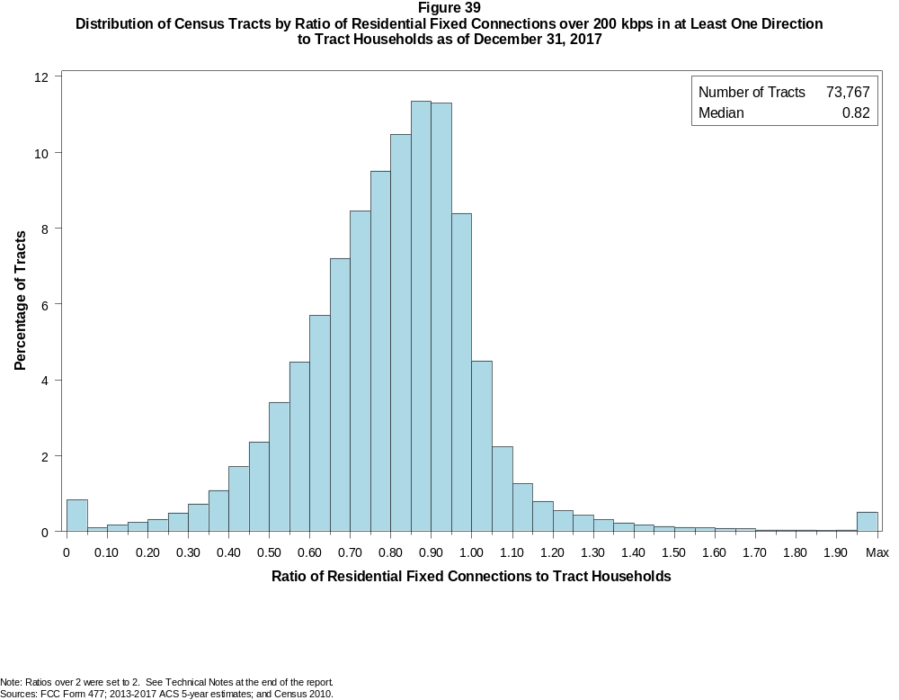

Figure 40
Distribution of Census Tracts by Ratio of Residential Fixed Connections over 200 kbps in at Least One Direction
to Tract Households by Technology as of December 31, 2017

 | Ratio of Residential Fixed Connections to Tract Households
Technology | Zero | Greater than 0 and no more than 5% | Greater than 5 and no more than 10% | Greater than 10 and no more than 20% | Greater than 20 and no more than 30% | Greater than 30 and no more than 40% | Greater than 40 and no more than 50% | Greater than 50 and no more than 60% | Greater than 60 and no more than 80% | Greater than 80 and no more than 100% | 100% or more
aDSL | 2.5 | 20.9 | 13.5 | 25.2 | 19.0 | 11.1 | 4.7 | 1.9 | 1.0 | 0.2 | 0.2
sDSL | 99.1 | 0.8 | 0.0 | 0.0 | 0.0 | 0.0 | 0.0 | 0.0 | 0.0 | 0.0 | 0.0
Other Wireline | 98.4 | 1.3 | 0.1 | 0.1 | 0.0 | 0.0 | 0.0 | 0.0 | 0.0 | 0.0 | 0.0
Cable Modem | 4.7 | 2.8 | 1.7 | 4.0 | 6.6 | 12.0 | 17.0 | 18.9 | 23.8 | 6.6 | 1.9
FTTP | 44.8 | 19.7 | 6.5 | 9.2 | 6.0 | 4.9 | 3.8 | 2.5 | 2.2 | 0.3 | 0.1
Satellite | 35.4 | 55.2 | 5.0 | 3.1 | 0.8 | 0.2 | 0.1 | 0.0 | 0.0 | 0.0 | 0.0
Fixed Wireless | 74.2 | 19.9 | 2.6 | 2.1 | 0.7 | 0.3 | 0.1 | 0.0 | 0.0 | 0.0 | 0.0
Total | 0.8 | 0.1 | 0.1 | 0.4 | 0.8 | 1.8 | 4.1 | 7.9 | 30.9 | 41.5 | 11.6

¹ Power Line and Other are summarized with Other Wireline. See Technical Notes at the end of the report for a description of Form 477 technology categories and other reporting requirements.
Note: Figures may not sum to totals due to rounding.
Sources: FCC Form 477; 2013-2017 ACS 5-year estimates; and Census 2010.

Figure 41
Percentage of Developed Census Blocks with Residential Fixed Service by Technology as of December 31, 2017
(Internet Access Service over 200 kbps in at least one direction)

 | Number of Providers
Technology | Zero | One | Two | Three | Four | Five | Six | Seven or More
aDSL | 24.4 | 72.8 | 2.7 | 0.1 | 0.0 | 0.0 | 0.0 | 0.0
sDSL | 99.3 | 0.7 | 0.0 | 0.0 | 0.0 | 0.0 | 0.0 | 0.0
Other Wireline¹ | 98.8 | 1.1 | 0.0 | 0.0 | 0.0 | 0.0 | 0.0 | 0.0
Cable Modem | 54.6 | 42.7 | 2.4 | 0.3 | 0.0 | 0.0 | 0.0 | 0.0
FTTP | 78.1 | 19.8 | 2.0 | 0.1 | 0.0 | 0.0 | 0.0 | 0.0
Satellite | 0.0 | 0.1 | 1.0 | 98.8 | 0.0 | 0.0 | 0.0 | 0.0
Fixed Wireless | 56.7 | 27.6 | 11.2 | 3.7 | 0.7 | 0.1 | 0.0 | 0.0
aDSL and/or Cable Modem and/or FTTP | 13.3 | 42.6 | 37.2 | 6.3 | 0.5 | 0.0 | 0.0 | 0.0
Any Technology | 0.0 | 0.1 | 0.2 | 5.6 | 18.1 | 40.7 | 23.3 | 12.0

¹ Power Line and Other are summarized with Other Wireline. See Technical Notes at the end of the report for a description of Form 477 technology categories and other reporting requirements.
Note: Figures may not sum to totals due to rounding. The number of providers in a census block does not necessarily reflect the number of choices available to a particular household, and does not
purport to measure competition. Providers may list a census block on Form 477 if service can be provided to at least one location in the block. Developed census blocks are those with housing units
based on the 2010 census.
Sources: FCC Form 477 and Census 2010.

Figure 42
Distribution of Counties by Ratio of Residential Fixed Connections to County Households by State as of December 31, 2017
(Connections over 200 kbps in at least one direction)

 |  | Ratio of Residential Fixed Connections over 200 kbps in at Least One Direction to County Households
State | Counties | Zero | Greater than 0 and no more than 5% | Greater than 5 and no more than 10% | Greater than 10 and no more than 20% | Greater than 20 and no more than 30% | Greater than 30 and no more than 40% | Greater than 40 and no more than 50% | Greater than 50 and no more than 60% | Greater than 60 and no more than 80% | Greater than 80 and no more than 100% | 100% or more
Alabama | 67 | 0 | 0 | 0 | 0 | 0 | 2 | 16 | 19 | 23 | 7 | 0
Alaska | 29 | 0 | 0 | 0 | 0 | 1 | 2 | 3 | 2 | 9 | 9 | 3
American Samoa | 5 | 2 | 0 | 0 | 0 | 2 | 1 | 0 | 0 | 0 | 0 | 0
Arizona | 15 | 0 | 0 | 0 | 0 | 0 | 0 | 1 | 1 | 7 | 6 | 0
Arkansas | 75 | 0 | 0 | 0 | 0 | 0 | 5 | 20 | 28 | 20 | 2 | 0
California | 58 | 0 | 0 | 0 | 0 | 0 | 0 | 0 | 0 | 20 | 35 | 3
Colorado | 64 | 0 | 0 | 0 | 0 | 0 | 1 | 3 | 7 | 21 | 22 | 10
Connecticut | 8 | 0 | 0 | 0 | 0 | 0 | 0 | 0 | 0 | 0 | 8 | 0
Delaware | 3 | 0 | 0 | 0 | 0 | 0 | 0 | 0 | 0 | 0 | 2 | 1
District of Columbia | 1 | 0 | 0 | 0 | 0 | 0 | 0 | 0 | 0 | 0 | 1 | 0
Florida | 67 | 0 | 0 | 0 | 0 | 0 | 0 | 0 | 7 | 17 | 28 | 15
Georgia | 159 | 0 | 0 | 0 | 1 | 2 | 10 | 20 | 29 | 59 | 31 | 7
Guam | 1 | 0 | 0 | 0 | 0 | 0 | 0 | 0 | 0 | 0 | 1 | 0
Hawaii | 5 | 1 | 0 | 0 | 0 | 0 | 0 | 0 | 0 | 1 | 1 | 2
Idaho | 44 | 0 | 0 | 0 | 0 | 0 | 0 | 0 | 4 | 27 | 10 | 3
Illinois | 102 | 0 | 0 | 0 | 0 | 0 | 1 | 2 | 18 | 68 | 13 | 0
Indiana | 92 | 0 | 0 | 0 | 0 | 0 | 0 | 1 | 20 | 59 | 12 | 0
Iowa | 99 | 0 | 0 | 0 | 0 | 0 | 0 | 1 | 9 | 83 | 5 | 1
Kansas | 105 | 0 | 0 | 0 | 0 | 0 | 1 | 4 | 12 | 72 | 16 | 0
Kentucky | 120 | 0 | 0 | 0 | 0 | 1 | 1 | 10 | 22 | 74 | 12 | 0
Louisiana | 64 | 0 | 0 | 0 | 0 | 0 | 5 | 12 | 11 | 29 | 7 | 0
Maine | 16 | 0 | 0 | 0 | 0 | 0 | 0 | 0 | 0 | 7 | 7 | 2
Maryland | 24 | 0 | 0 | 0 | 0 | 0 | 0 | 0 | 1 | 8 | 14 | 1
Massachusetts | 14 | 0 | 0 | 0 | 0 | 0 | 0 | 0 | 0 | 2 | 9 | 3
Michigan | 83 | 0 | 0 | 0 | 0 | 0 | 0 | 4 | 7 | 53 | 18 | 1
Minnesota | 87 | 0 | 0 | 0 | 0 | 0 | 1 | 0 | 2 | 63 | 20 | 1
Mississippi | 82 | 0 | 0 | 0 | 1 | 1 | 14 | 28 | 22 | 13 | 3 | 0
Missouri | 115 | 0 | 0 | 0 | 0 | 3 | 6 | 11 | 20 | 63 | 10 | 2
Montana | 56 | 0 | 0 | 0 | 0 | 0 | 0 | 0 | 7 | 32 | 16 | 1
Nebraska | 93 | 0 | 0 | 0 | 0 | 0 | 2 | 9 | 22 | 57 | 3 | 0

Figure 42 - Continued
Distribution of Counties by Ratio of Residential Fixed Connections to County Households by State as of December 31, 2017
(Connections over 200 kbps in at least one direction)

 |  | Ratio of Residential Fixed Connections over 200 kbps in at Least One Direction to County Households
State | Counties | Zero | Greater than 0 and no more than 5% | Greater than 5 and no more than 10% | Greater than 10 and no more than 20% | Greater than 20 and no more than 30% | Greater than 30 and no more than 40% | Greater than 40 and no more than 50% | Greater than 50 and no more than 60% | Greater than 60 and no more than 80% | Greater than 80 and no more than 100% | 100% or more
Nevada | 17 | 0 | 0 | 0 | 0 | 1 | 1 | 0 | 3 | 7 | 5 | 0
New Hampshire | 10 | 0 | 0 | 0 | 0 | 0 | 0 | 0 | 1 | 1 | 6 | 2
New Jersey | 21 | 0 | 0 | 0 | 0 | 0 | 0 | 0 | 0 | 1 | 19 | 1
New Mexico | 33 | 0 | 0 | 0 | 1 | 1 | 2 | 2 | 6 | 17 | 3 | 1
New York | 62 | 0 | 0 | 0 | 0 | 0 | 0 | 0 | 0 | 36 | 24 | 2
North Carolina | 100 | 0 | 0 | 0 | 0 | 0 | 0 | 1 | 15 | 46 | 31 | 7
North Dakota | 53 | 0 | 0 | 0 | 0 | 0 | 0 | 1 | 7 | 31 | 13 | 1
Northern Mariana Isl | 4 | 1 | 0 | 0 | 0 | 0 | 0 | 3 | 0 | 0 | 0 | 0
Ohio | 88 | 0 | 0 | 0 | 0 | 0 | 0 | 2 | 8 | 60 | 18 | 0
Oklahoma | 77 | 0 | 0 | 0 | 0 | 1 | 4 | 13 | 24 | 33 | 2 | 0
Oregon | 36 | 0 | 0 | 0 | 0 | 0 | 0 | 1 | 1 | 19 | 14 | 1
Pennsylvania | 67 | 0 | 0 | 0 | 0 | 0 | 0 | 1 | 1 | 38 | 23 | 4
Puerto Rico | 78 | 0 | 0 | 0 | 0 | 3 | 14 | 25 | 30 | 6 | 0 | 0
Rhode Island | 5 | 0 | 0 | 0 | 0 | 0 | 0 | 0 | 0 | 0 | 5 | 0
South Carolina | 46 | 0 | 0 | 0 | 0 | 0 | 0 | 7 | 11 | 17 | 9 | 2
South Dakota | 66 | 0 | 0 | 0 | 0 | 0 | 1 | 5 | 5 | 45 | 9 | 1
Tennessee | 95 | 0 | 0 | 0 | 0 | 0 | 1 | 8 | 23 | 53 | 10 | 0
Texas | 254 | 0 | 1 | 0 | 0 | 0 | 5 | 28 | 62 | 112 | 37 | 9
Utah | 29 | 0 | 0 | 0 | 0 | 0 | 0 | 0 | 1 | 10 | 12 | 6
Vermont | 14 | 0 | 0 | 0 | 0 | 0 | 0 | 0 | 0 | 3 | 10 | 1
Virgin Islands | 3 | 0 | 0 | 0 | 0 | 0 | 0 | 0 | 2 | 0 | 0 | 1
Virginia | 134 | 0 | 0 | 0 | 1 | 0 | 7 | 14 | 16 | 60 | 34 | 2
Washington | 39 | 0 | 0 | 0 | 0 | 0 | 0 | 1 | 2 | 14 | 21 | 1
West Virginia | 55 | 0 | 0 | 0 | 0 | 1 | 0 | 1 | 3 | 42 | 8 | 0
Wisconsin | 72 | 0 | 0 | 0 | 0 | 0 | 0 | 0 | 1 | 49 | 20 | 2
Wyoming | 23 | 0 | 0 | 0 | 0 | 0 | 0 | 1 | 2 | 13 | 6 | 1
Total | 3,234 | 4 | 1 | 0 | 4 | 17 | 87 | 259 | 494 | 1600 | 667 | 101

Note: Figures may not sum to totals due to rounding. See Technical Notes at the end of the report.
Sources: FCC Form 477; 2013-2017 ACS 5-year estimates (Households for U.S. and District of Columbia); Census 2010 (Households for Puerto Rico, American Samoa,
Guam, Northern Mariana Islands and U.S. Virgin Islands).

Figure 43
Distribution of Census Tracts by Ratio of Residential Fixed Connections to Tract Households by State as of December 31, 2017
(Connections over 200 kbps in at least one direction)

 |  | Ratio of Residential Fixed Connections over 200 kbps in at Least One Direction to Tract Households
State | Tracts | Zero | Greater than 0 and no more than 5% | Greater than 5 and no more than 10% | Greater than 10 and no more than 20% | Greater than 20 and no more than 30% | Greater than 30 and no more than 40% | Greater than 40 and no more than 50% | Greater than 50 and no more than 60% | Greater than 60 and no more than 80% | Greater than 80 and no more than 100% | 100% or more
Alabama | 1,179 | 4 | 0 | 1 | 5 | 17 | 78 | 137 | 204 | 413 | 252 | 68
Alaska | 167 | 2 | 0 | 0 | 3 | 6 | 2 | 5 | 12 | 51 | 69 | 17
American Samoa | 18 | 2 | 0 | 0 | 1 | 8 | 5 | 0 | 0 | 0 | 1 | 1
Arizona | 1,526 | 14 | 7 | 8 | 9 | 17 | 22 | 42 | 120 | 375 | 589 | 323
Arkansas | 686 | 1 | 0 | 1 | 5 | 12 | 62 | 106 | 124 | 226 | 122 | 27
California | 8,036 | 54 | 3 | 5 | 9 | 22 | 46 | 96 | 313 | 1,943 | 4,589 | 956
Colorado | 1,249 | 14 | 1 | 0 | 0 | 4 | 9 | 20 | 38 | 299 | 648 | 216
Connecticut | 829 | 2 | 0 | 0 | 0 | 2 | 1 | 8 | 34 | 154 | 509 | 119
Delaware | 215 | 1 | 0 | 0 | 0 | 1 | 0 | 2 | 11 | 53 | 97 | 50
District of Columbia | 179 | 1 | 0 | 0 | 0 | 1 | 0 | 4 | 11 | 57 | 74 | 31
Florida | 4,199 | 38 | 0 | 1 | 4 | 3 | 19 | 70 | 161 | 768 | 1,835 | 1,300
Georgia | 1,964 | 11 | 2 | 0 | 3 | 13 | 63 | 132 | 202 | 594 | 687 | 257
Guam | 56 | 8 | 0 | 2 | 4 | 1 | 3 | 3 | 3 | 11 | 6 | 15
Hawaii | 326 | 14 | 0 | 0 | 3 | 0 | 6 | 6 | 12 | 59 | 131 | 95
Idaho | 298 | 0 | 0 | 0 | 1 | 2 | 2 | 5 | 23 | 136 | 102 | 27
Illinois | 3,121 | 6 | 0 | 1 | 3 | 10 | 34 | 142 | 298 | 1,176 | 1,289 | 162
Indiana | 1,508 | 4 | 1 | 1 | 3 | 8 | 19 | 82 | 198 | 656 | 457 | 79
Iowa | 825 | 3 | 0 | 0 | 1 | 2 | 4 | 20 | 84 | 510 | 184 | 17
Kansas | 770 | 11 | 0 | 0 | 0 | 1 | 11 | 37 | 92 | 323 | 226 | 69
Kentucky | 1,115 | 10 | 2 | 0 | 11 | 11 | 30 | 61 | 161 | 446 | 340 | 43
Louisiana | 1,136 | 12 | 1 | 0 | 3 | 17 | 67 | 91 | 169 | 416 | 306 | 54
Maine | 351 | 0 | 0 | 0 | 0 | 0 | 0 | 0 | 8 | 113 | 173 | 57
Maryland | 1,394 | 9 | 0 | 0 | 0 | 1 | 15 | 39 | 74 | 308 | 748 | 200
Massachusetts | 1,471 | 11 | 1 | 0 | 0 | 2 | 1 | 9 | 34 | 303 | 897 | 213
Michigan | 2,767 | 28 | 1 | 1 | 10 | 24 | 98 | 185 | 273 | 839 | 1,145 | 163
Minnesota | 1,335 | 4 | 0 | 1 | 1 | 3 | 5 | 33 | 57 | 564 | 594 | 73
Mississippi | 661 | 4 | 0 | 0 | 4 | 23 | 87 | 126 | 130 | 184 | 90 | 13
Missouri | 1,393 | 4 | 0 | 1 | 7 | 15 | 39 | 111 | 197 | 463 | 481 | 75
Montana | 271 | 2 | 0 | 0 | 1 | 0 | 2 | 7 | 20 | 109 | 110 | 20
Nebraska | 532 | 4 | 0 | 0 | 0 | 0 | 5 | 23 | 49 | 246 | 172 | 33

Figure 43 - Continued
Distribution of Census Tracts by Ratio of Residential Fixed Connections to Tract Households by State as of December 31, 2017
(Connections over 200 kbps in at least one direction)

 |  | Ratio of Residential Fixed Connections over 200 kbps in at Least One Direction to Tract Households
State | Tracts | Zero | Greater than 0 and no more than 5% | Greater than 5 and no more than 10% | Greater than 10 and no more than 20% | Greater than 20 and no more than 30% | Greater than 30 and no more than 40% | Greater than 40 and no more than 50% | Greater than 50 and no more than 60% | Greater than 60 and no more than 80% | Greater than 80 and no more than 100% | 100% or more
Nevada | 683 | 5 | 0 | 2 | 2 | 4 | 5 | 18 | 40 | 179 | 313 | 115
New Hampshire | 294 | 2 | 0 | 0 | 0 | 0 | 4 | 9 | 5 | 43 | 170 | 61
New Jersey | 2,004 | 11 | 0 | 0 | 0 | 1 | 3 | 9 | 33 | 397 | 1,145 | 405
New Mexico | 499 | 2 | 3 | 2 | 9 | 13 | 17 | 25 | 78 | 194 | 128 | 28
New York | 4,900 | 74 | 1 | 3 | 11 | 17 | 15 | 45 | 170 | 1,574 | 2,389 | 601
North Carolina | 2,183 | 21 | 1 | 0 | 1 | 4 | 16 | 59 | 168 | 763 | 818 | 332
North Dakota | 205 | 0 | 0 | 0 | 0 | 0 | 0 | 9 | 20 | 104 | 54 | 18
Northern Mariana Isl | 22 | 2 | 0 | 0 | 0 | 1 | 6 | 6 | 2 | 5 | 0 | 0
Ohio | 2,946 | 7 | 0 | 0 | 1 | 10 | 31 | 113 | 299 | 1,157 | 1,173 | 155
Oklahoma | 1,046 | 2 | 2 | 2 | 12 | 34 | 41 | 130 | 177 | 357 | 220 | 69
Oregon | 827 | 2 | 0 | 0 | 0 | 0 | 6 | 17 | 30 | 261 | 446 | 65
Pennsylvania | 3,217 | 21 | 0 | 1 | 4 | 10 | 13 | 56 | 189 | 1,295 | 1,374 | 254
Puerto Rico | 903 | 21 | 31 | 34 | 124 | 149 | 142 | 138 | 63 | 73 | 32 | 96
Rhode Island | 241 | 1 | 0 | 0 | 0 | 0 | 0 | 2 | 2 | 62 | 142 | 32
South Carolina | 1,097 | 12 | 0 | 0 | 1 | 9 | 23 | 88 | 132 | 366 | 318 | 148
South Dakota | 222 | 0 | 0 | 0 | 2 | 0 | 4 | 11 | 13 | 118 | 62 | 12
Tennessee | 1,497 | 21 | 1 | 0 | 6 | 14 | 54 | 105 | 210 | 557 | 433 | 96
Texas | 5,253 | 40 | 1 | 1 | 19 | 61 | 158 | 390 | 695 | 1,595 | 1,656 | 637
Utah | 588 | 4 | 2 | 3 | 0 | 0 | 1 | 3 | 7 | 146 | 349 | 73
Vermont | 184 | 1 | 0 | 0 | 0 | 0 | 1 | 0 | 0 | 51 | 98 | 33
Virgin Islands | 29 | 0 | 0 | 0 | 2 | 1 | 2 | 7 | 5 | 8 | 2 | 2
Virginia | 1,895 | 23 | 0 | 0 | 5 | 18 | 42 | 85 | 166 | 458 | 816 | 282
Washington | 1,446 | 2 | 1 | 0 | 0 | 4 | 8 | 19 | 32 | 304 | 885 | 191
West Virginia | 484 | 0 | 1 | 1 | 2 | 6 | 12 | 32 | 50 | 221 | 129 | 30
Wisconsin | 1,393 | 3 | 1 | 3 | 16 | 13 | 8 | 30 | 91 | 640 | 523 | 65
Wyoming | 132 | 1 | 0 | 0 | 1 | 0 | 1 | 6 | 9 | 60 | 47 | 7
Total | 73,767 | 556 | 64 | 75 | 309 | 595 | 1,348 | 3,014 | 5,798 | 22,783 | 30,645 | 8,580

Note: Figures may not sum to totals due to rounding. See Technical Notes at the end of the report.
Sources: FCC Form 477; 2013-2017 ACS 5-year estimates (Households for U.S. and District of Columbia); Census 2010 (Households for Puerto Rico, American Samoa,
Guam, Northern Mariana Islands and U.S. Virgin Islands).

